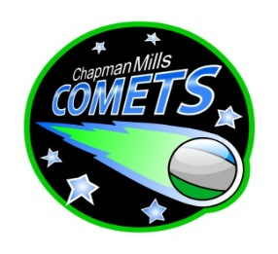
Chapman Mills Public School

School Council Agenda for January 18, 2024
6:30pm – 8:00pm
Chapman Mills Public School – Staffroom

Item | Agenda topic | Presenter | Time (min)
 | Welcome  - Land Acknowledgement  - Review Agenda  - Approve minutes of previous Council Meeting | Trish Taylor | 5
 | Principal’s Update | Paul McAnany/ Bethany Pye | 15
 | Teachers’ Update | Cynthia Roberts/ Andrea Hardy | 10
 | Finance Update  - Discussion on use of funds to support School Field Trips and Library enhancements | Will McCarthy /  Trish Taylor | 10
 | Communications Update | Melina Larizza | 5
 | Fundraising/Events Update  - Snowflake Dance – Event was well-received with ~400-450 people in attendance. The cost was off-set by the snack table ($615 before expenses)  - Future proposed activities:  - February 23: Magic Show  - May: Jump Rope for Heart Fundraiser  - June: Kinder night | Mary Melady | 15
 | Hot Lunch Program Update  - Hot Lunch program Term 2 starts January 18 for Pizza (Topper’s) and January 23 for Subway  - Term 2 runs until March Break | Nivedita Muthukumarasamy | 5
 | PRO grant  - Submitted with a request for $750 to fund a webinar through Egale Canada - Faith and 2SLGBTQI  - Target date: April 2024 | Melina Larizza/ Trish Taylor | 5
 | Year-end Event Update | Melina Larizza/  Nima Orazani/ Bryan Brunet/ Manosila Yoganathan | 5
 | Housekeeping  - Constitution sub-committee | Trish Taylor | 5
 | Round Table / Q&A | All | 10

